**Aryan Rathee**

**190123013**

**MA323 Midsem Lab Report**

1. Histogram for n=1000 Zoomed in view of the same histogram

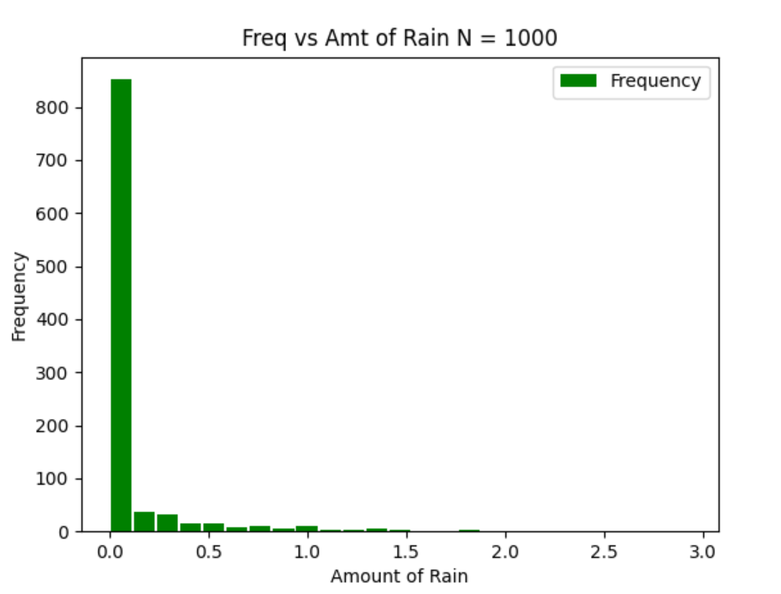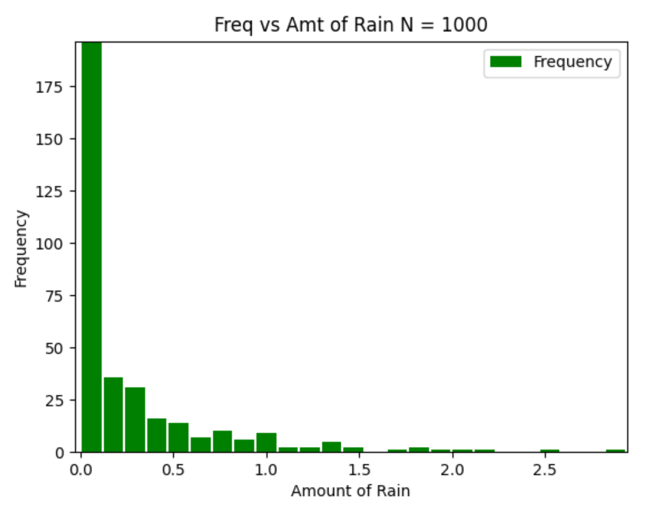

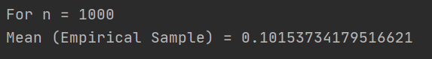

The distribution of the rain will be of the form **2*e^(-2*x)** and the corresponding **CDF** will **be 1-e^(-2*x)** and when we calculate F^-1(U) for this function it comes out to be **-2*log(1-U)** which has same distribution as **-2*log(U).** Moreover, the rain occurs only 20% of the days, so I also generate another random variable, u2 and if **u2<=0.2**, then I consider that rain has occurred on that day otherwise I consider that no rain occurred, so the amount of rain will be 0 for that day.

The histogram also depicts the same thing, for about **800 days there is no rain** and the rest of the graph has exponential distribution, the distribution is not so close to the actual one because the sample size (n=1000) is small.

The mean is also very close to the expected value which is mean=**0.101537**

2.

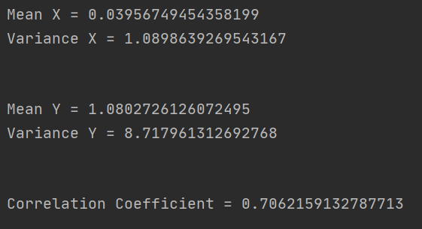

X is generated simply by using Box muller method, now the mean of Y is 2*X+1, so foe each generated X we will make Y=2*X+1+2*Z2, where is Z2 is the random number generated by uniform distribution. Because for generating a distribution of the form N(mean, variance), we need to first generate N(0,1) and then multiply each of its number by sqrt(variance) and add mean to each of the number generated, it is the same process just the difference is that here mean for each variable is different. Then we generate mean and variance for the distributions X and Y.

Now to calculate correlation coefficient, we need to find covariance matrix which is found by inbuilt numpy function and then we simply calculate rho=cov[0][1]/sqrt(cov[0][0]*cov[1][1]) i.e. sigma1*sigma2*rho/sqrt((sigma1*sigma)^2) where cov is covariance matrix.

3.

a. We can take g(x) also as the same function with the difference what v=1, because in that case we can find out the distribution comparatively very easily and can then proceed with acceptance rejection method.

b. The acceptance probability will be 1/c where c is the c is the acceptance-rejection constant which is equal to 1 as f(x,1)>=f(x,3.2)

c. The portion of accepted values will be very close to 1/c i.e. all values will be accepted as c=1.